**Thermal Conduction in Metals**

**Aim:** To investigate the rate of thermal conduction in different metals.

**Equipment:**

* four metal rods – aluminium, brass, copper and iron
* tripod
* heatproof mat
* Bunsen burner
* candle wax
* matches
* stopwatch

**Procedure:**

1. Place the rods on the tripod (without a gauze) so that the inner ends are over the Bunsen burner.
2. Ensure that the metal rods are placed so candle wax is on the top surface.
3. Heat the rods with a blue flame at the end where they touch each other.
4. Observe the rods and record the amount of time it takes for the wax on each metal to melt.
5. Turn off the Bunsen burner and allow to cool, so that the wax can be reused.

**Variables:**

|  |  |  |
| --- | --- | --- |
| *Independent Variable (change)* | *Dependent Variable (measure)* | *Controlled Variables  (same)* |
|  |  |  |

**Results:**

|  |  |
| --- | --- |
| Metal | Time (min) |
|  |  |
|  |  |
|  |  |
|  |  |

**Discussion Questions:**

1. Which metal is the best thermal conductor? How do you know?
2. Why was it important that all the metal rods were the same size and length?
3. Can you suggest any ways to make this a more accurate experiment?

**Thermal Conduction in Water**

**Aim:** To show that water is a poor conductor of heat.

**Equipment:**

* test tube
* ice
* coil of wire or steel wool
* Bunsen burner
* heatproof mat
* retort stand
* boss head clamp
* glass rod

**Procedure:**

1. Put some ice in the bottom of the boiling tube.
2. Using the glass rod, push the coil of wire down the tube so that it will hold the ice at the bottom when the tube is filled with water.
3. 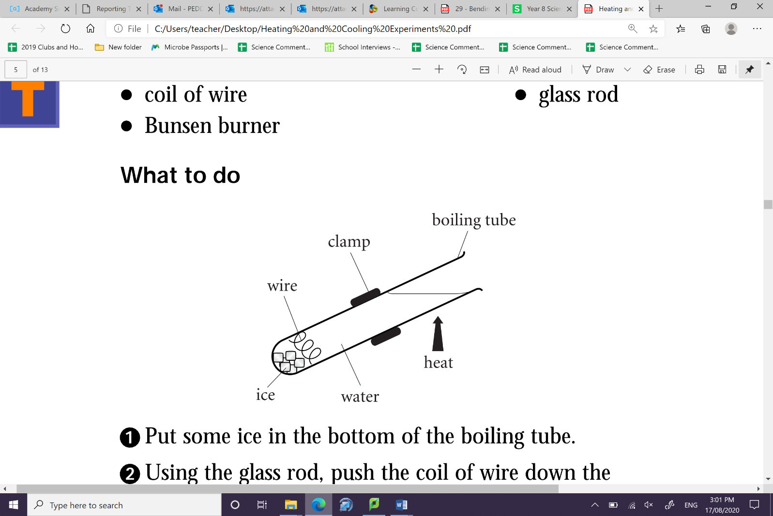Fill the tube to about 1 cm from the top with water.
4. Clamp the tube so that it is arranged as shown in the   
   diagram.
5. Heat the water at the top of the tube.
6. Observe the ice carefully.
7. When the water at the top of the tube starts to boil,   
   stop heating.

**Discussion Questions:**

1. What did you notice about the ice when the water at the top of the tube was boiling?
2. Is water a good conductor of heat? Explain how this experiment shows this.